**Wireframe for Whatsapp – searching for conversation.**

**Tool - Balsamiq**

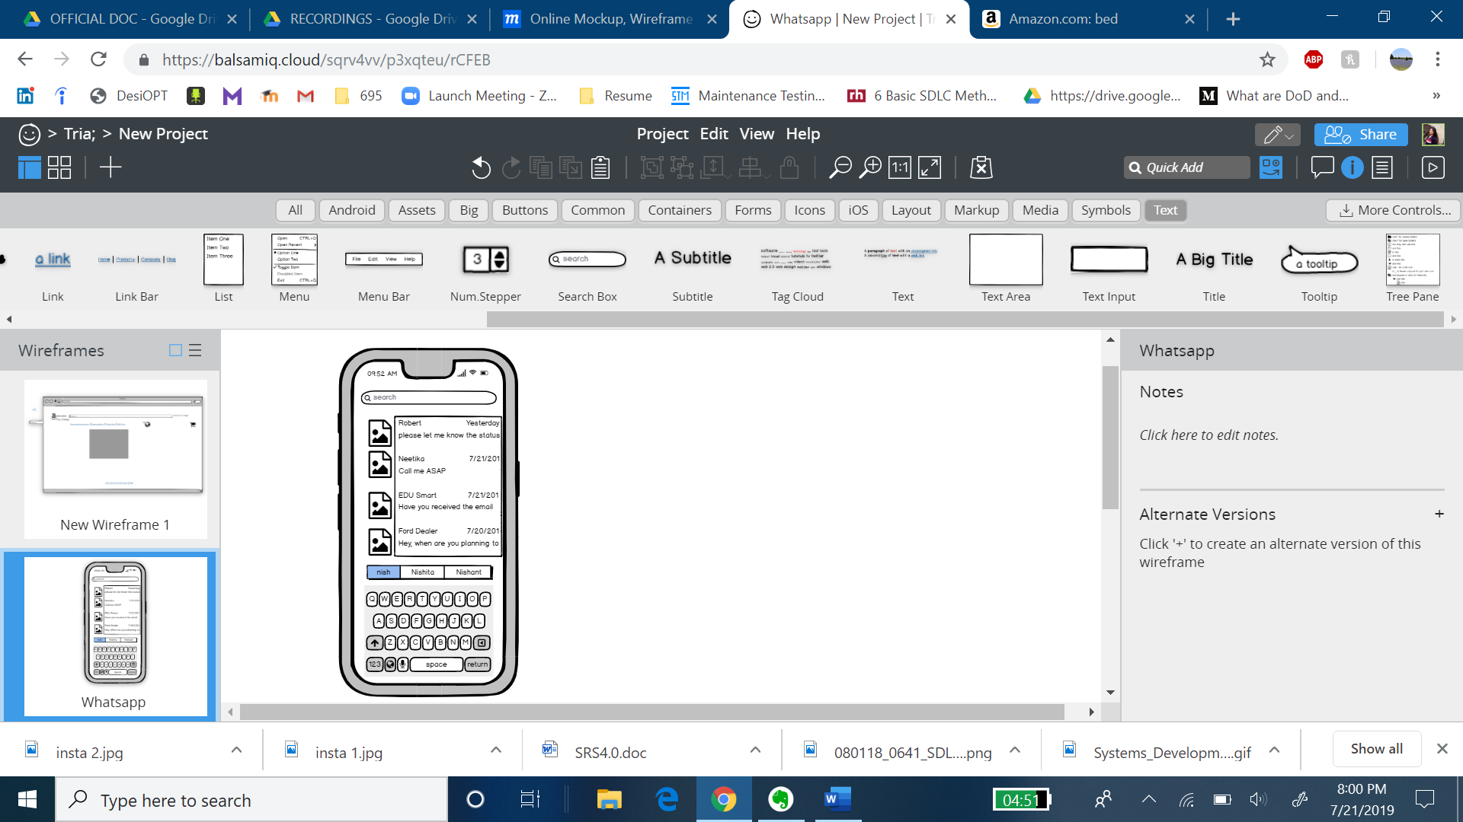

**Screenshot for reference**

